Day 18 – UI/UX Testing + Bug Tracking
Project: HisabDo Website
Task Type: Team-Based Task
Submitted By: Eshal Kamal

Objective
The objective of this task was to perform UI/UX testing of the HisabDo website and identify design, layout, spacing, alignment and visual consistency issues across different pages.

UI/UX Issues Identified

HOMEPAGE

1. Application Screens Section
- App screenshots are outdated.
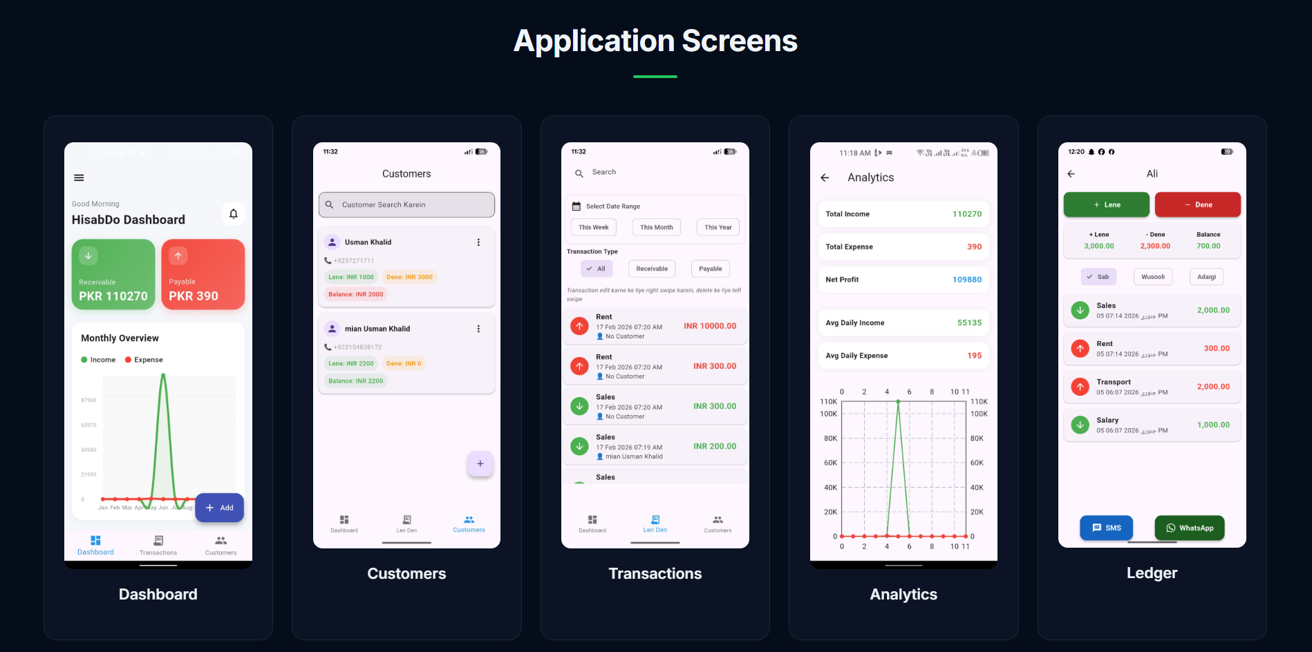
- App screenshots have inconsistent lengths.

2. Practical Tools for Shopkeepers, Freelancers & Small Business Owners Section
- The following div blocks are not properly aligned on the mobile screen and extend beyond the screen boundary:
  - Offline-first — Built for local use and low-connectivity environments
  - 5+ — Languages supported
  - 3 — Currencies supported
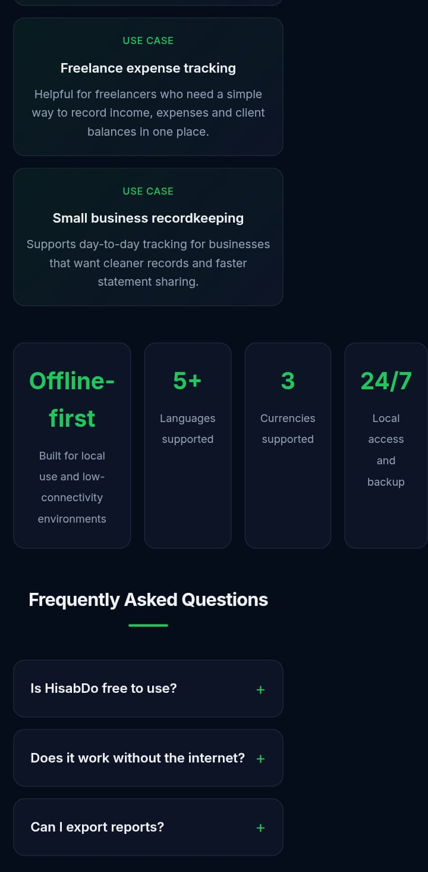
  - 24/7 — Local access and backup

3. Latest Blog Posts Section
- Within the div blocks, the paragraph and button do not have proper spacing.
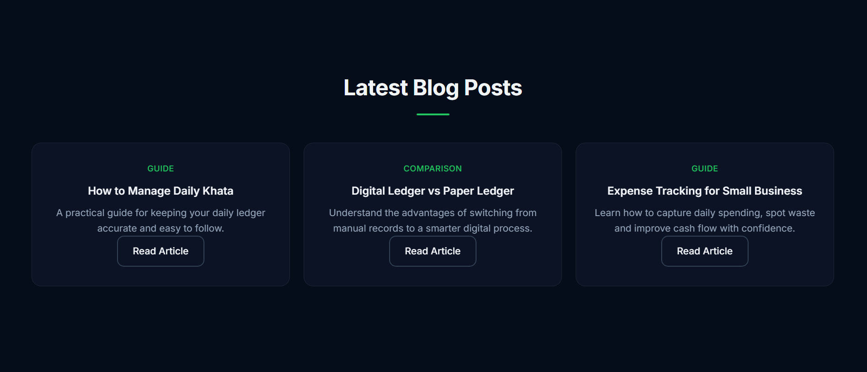

ABOUT

1. Why It Exists Section
- The app dashboard screenshot is outdated.

2. Privacy & Trust Section
- The app page screenshot is outdated.

3. Learn More Section
- Within the div blocks, the paragraph and button do not have proper spacing.
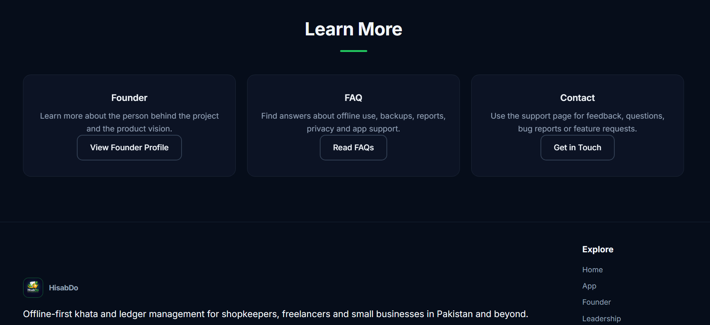

APP

1. A Day with HisabDo Section
- All app screenshots are outdated.

CAREERS

1. Open Roles Section
- There is no proper spacing between the different role div blocks.

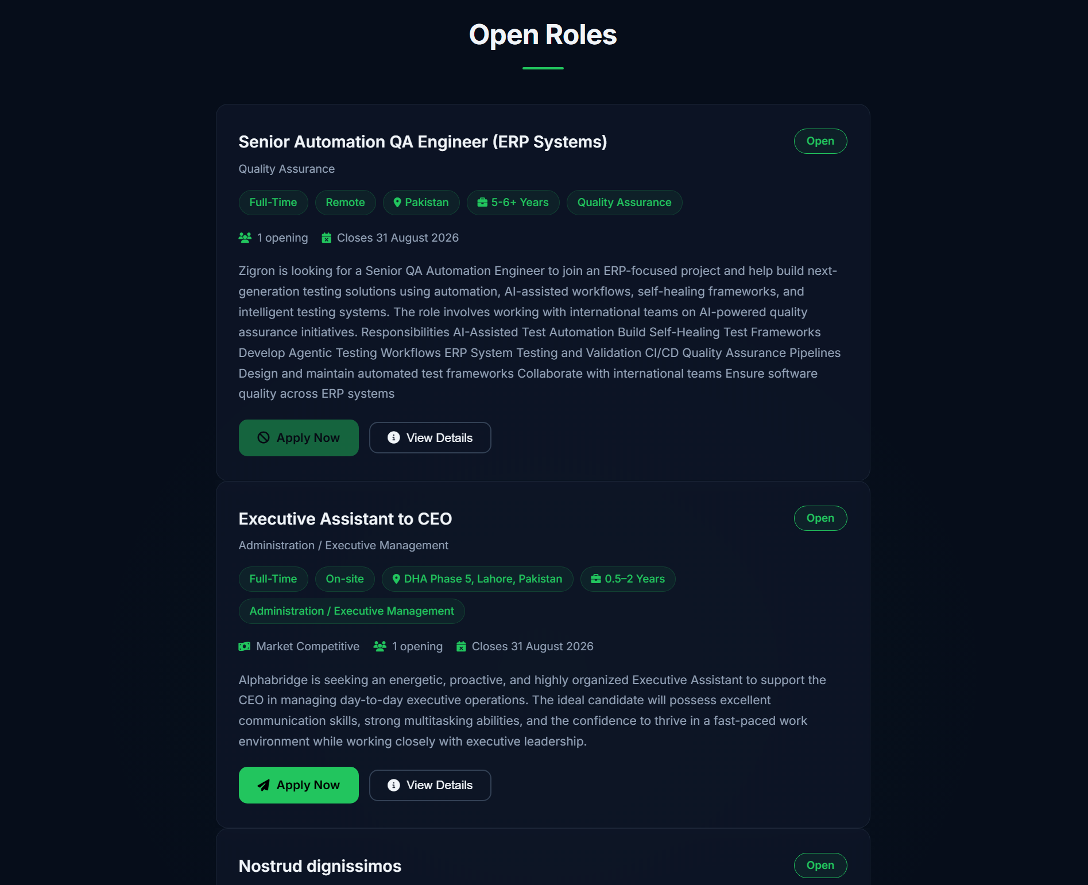

2. What We Look for Section
- This section has an inconsistent color scheme compared to the rest of the website.
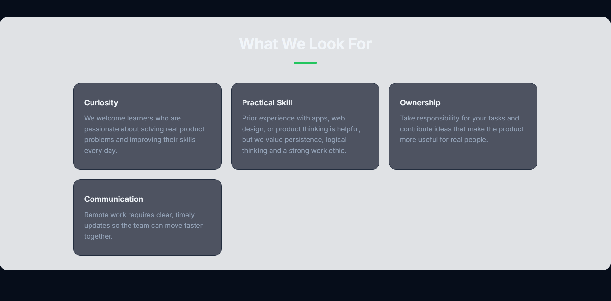

PRIVACY POLICY

1. Privacy Policy Content

- On a laptop or computer screen, the content between the “Privacy Policy” and “Questions About Privacy?” headings are not visible and a black div box is displayed instead.

Summary
A total of 10 UI/UX issues were identified across the assigned HisabDo website pages, including outdated images, alignment issues, spacing issues, inconsistent colors, mobile responsiveness issues and content visibility issues.

